OSCE July 2014 PMH

Question 1
A 16-months-old girl with good past health presented with sudden onset of vigorous cough and vomiting during food ingestion, associated with transient difficulty in breathing and cyanosis.
In ED, she was playful with RR 30/ min, SpO2 97% on room air.

CXR was performed.

- Please described the XR findings (Please include important negative findings)

- What is the most likely diagnosis?

- What are the physical findings to look for during initial assessment?

- What are the possible complications?

- What is the definitive treatment?

Question 2
A 50-year-old man complained of neck pain after fall injury. He failed to recall the landing mechanism.

XR C-spine was performed.

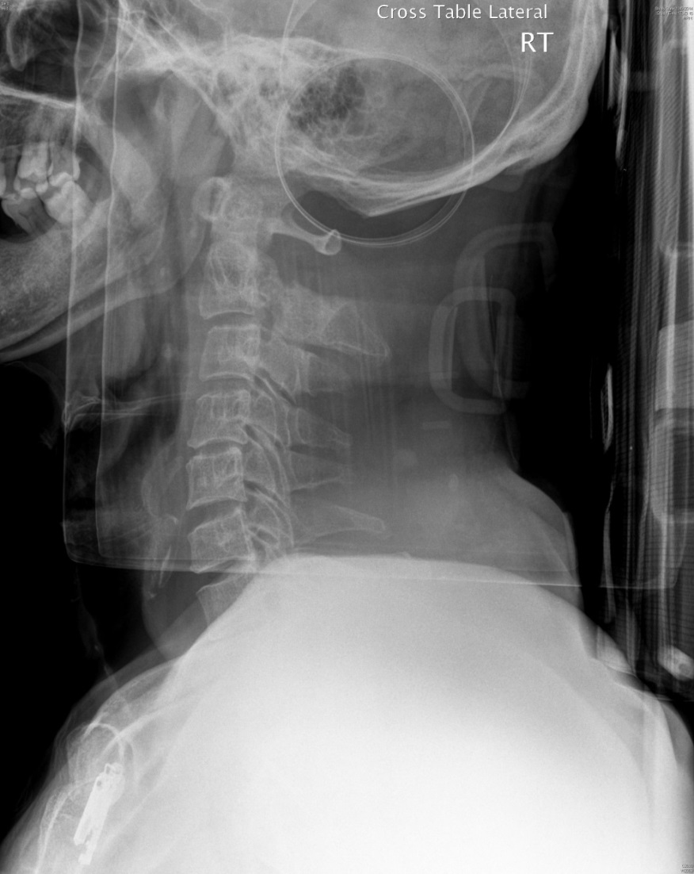

- Describe the x-ray abnormalities.

Non-contrast CT C-spine was performed.
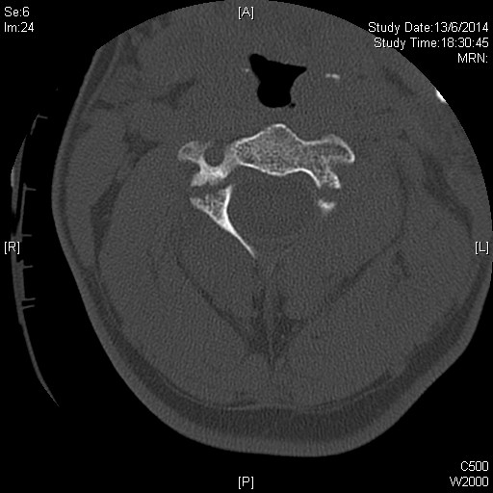

- What is the CT abnormality?

- What is the diagnosis?

- What is the common mechanism of injury for the above diagnosis?

- What are the potential complications?

- What is the classification of this disease?

Question 3

A 50-year-old man, with IHD and AF on warfarin (dosage of warfarin reduced in last follow-up), complained of chest discomfort, right upper limb numbness and weakness. There was no headache, vomiting, SOB, sweating or radiation of pain.
On physical exam,
- GCS 15/15, BP/P 210/100, pulse 90/min, Temp 36 C, Hstix 6.5
- Chest/CVS/abdomen unremarkable
- Upper Limb power right =4/5, left 5/5

- Name 3 differential diagnoses?

ECG was performed, showing AF without ischemic changes
CXR showed clear chest without widened mediastinum
CT brain showed no focal lesion

- What additional sign and symptoms will you look for?

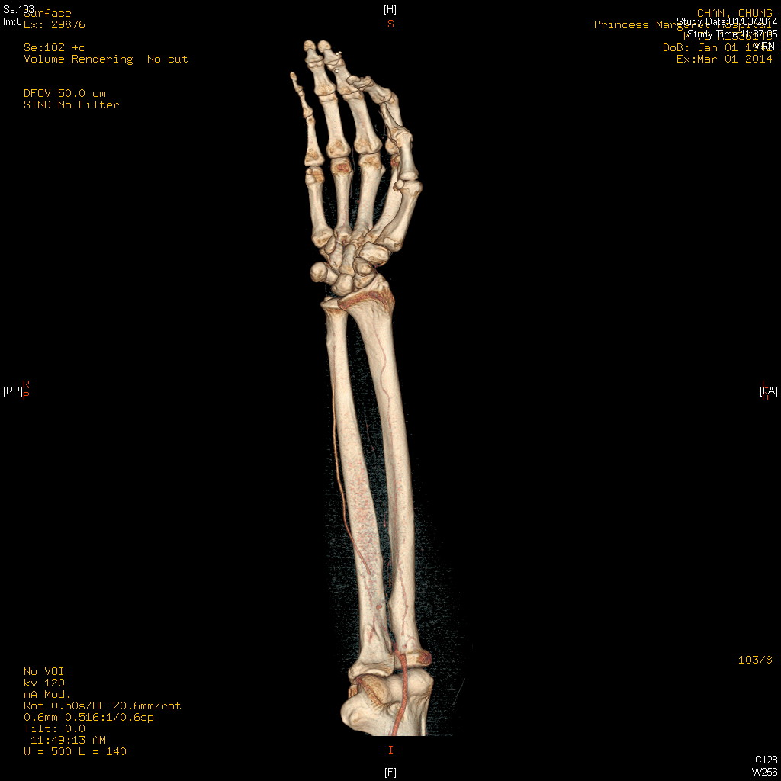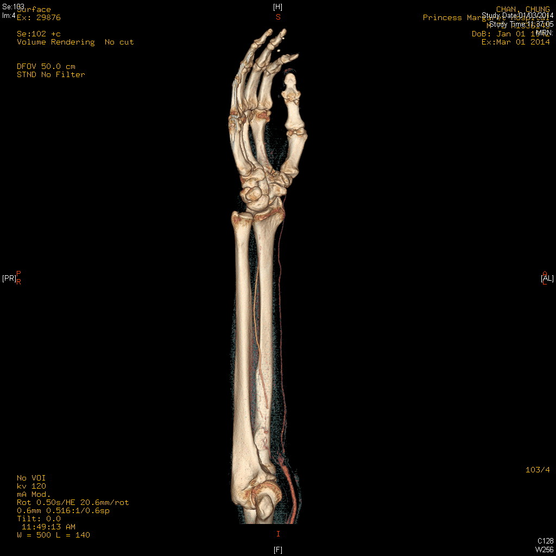

- What is the name of the above investigation? What and where is the lesion ?

- What is the definite treatment?

- After the treatment, what intravenous medication you can give to patient?

- What is the common dosage and how do you monitor the therapeutic effect and target of such therapy?

Question 4

A 57-year-old man with good past health, and is a never smoker and never drinker.
He attended AED complaining of ACUTE onset of dizziness with “difficulty in swallowing saliva”. There was no definite limb weakness/ numbness

Physical exam showed
- BP 144/93 P61 T 36.3 GCS 15/15
- Chest clear, HS dual no murmur
- Neurological exam:
  - Horizontal nystagmus +ve
  - Lt side past-pointing +ve, dysdiadochokinesia +ve
  - Decrease in pharyngeal-palatal elevation ?Loss of gag reflex
  - Other CN exam and sensory not commented in ED
  - Power of 4 limbs full

- What is the working clinical diagnosis?

- Which blood vessel is likely involved in this case?

In addition to the above clinical findings, there was loss of pain and temp sensation on the contralateral side of body and ipsilateral side of the face.

- What is the specific name of this syndrome?

CT brain on admission:
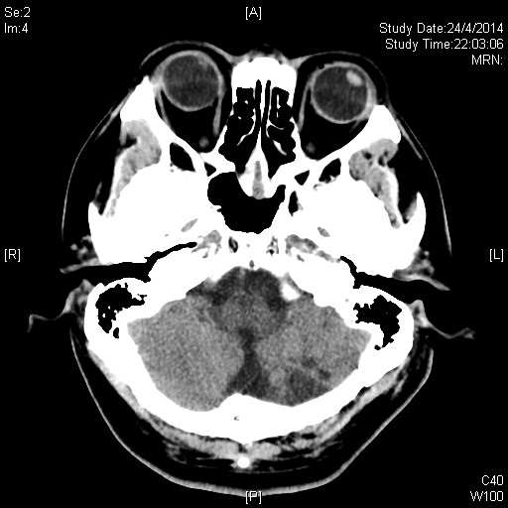

CT brain 5 days later:
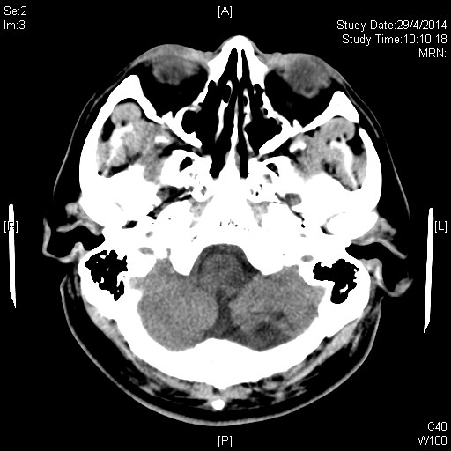

- Please describe the abnormalities of CT brain

- What further investigation should be performed?

Question 5

A 44-year-old woman came to AED as a road-traffic-accident victim. She was a passenger of a 7-seat van, sitting on back row of seat without wearing seat belt. She was thrown to front row of seat when the car crashed onto hill. She mainly complained of severe low back pain

XR LS spine was performed.
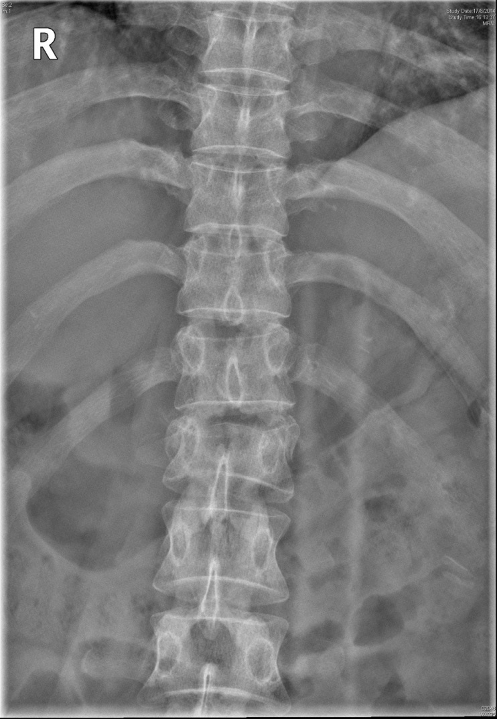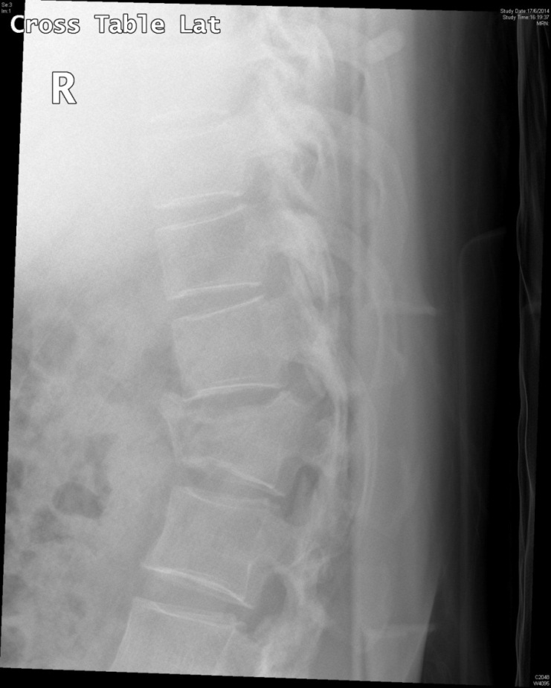

- Describe the X-ray finding

Subsequently CT TL spine was performed.

- Please describe the CT findings

- What is the name of this fracture?

- What is the mechanism of injury for this fracture?

- What is a common associated injury with this fracture?

